**Online Diary 7:**

**Date:** 14th December 2020

**7.0 Common games:**

Within the group, there was a discussion where common games between individuals was discovered and a common game was chosen to be made from digital to physical. The common games that was discovered where: fall guys, among us, Minecraft, rocket league and need for speed. The game that was chosen is Fall Guys.

**7.1 Game:**

Fall guys was decided to be developed into a board game being inspired from snakes and ladders. Players should expect to roll a die to be able to move further on the board. As it is inspired by snakes and ladders, players should expect to move from left to right slowly making their way up. In addition, trivia questions can move the player forward if answered correctly. Chance cards can move players forwards or backwards on the board by a certain amount of spaces.

**Implementations:**

Elements lifted from the game:

* Different ways to being kicked out
* Can get knocked back
* Race to the finish, with survival and trivia elements.

Elements left out from the game:

* Players don’t run with speed – a die is determined how many places to move forward.
* Players can’t get knocked out – only backwards
* There are not multiple maps
* Only one way to reach the finish line.

**Design:**

**The board:**

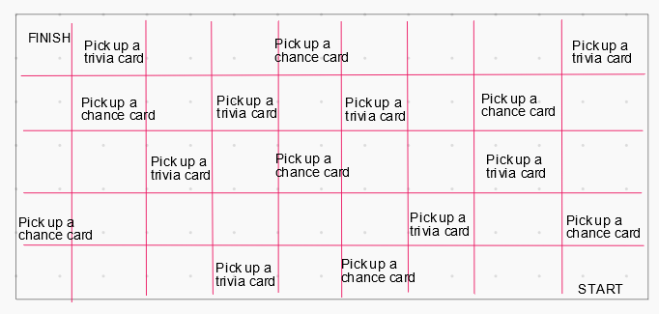

C

D

A

B

***Figure 1: [A] Design of the game board. [B] The start [C] Spaces that can be landed on [D] Finish line.***

**Chance card:**

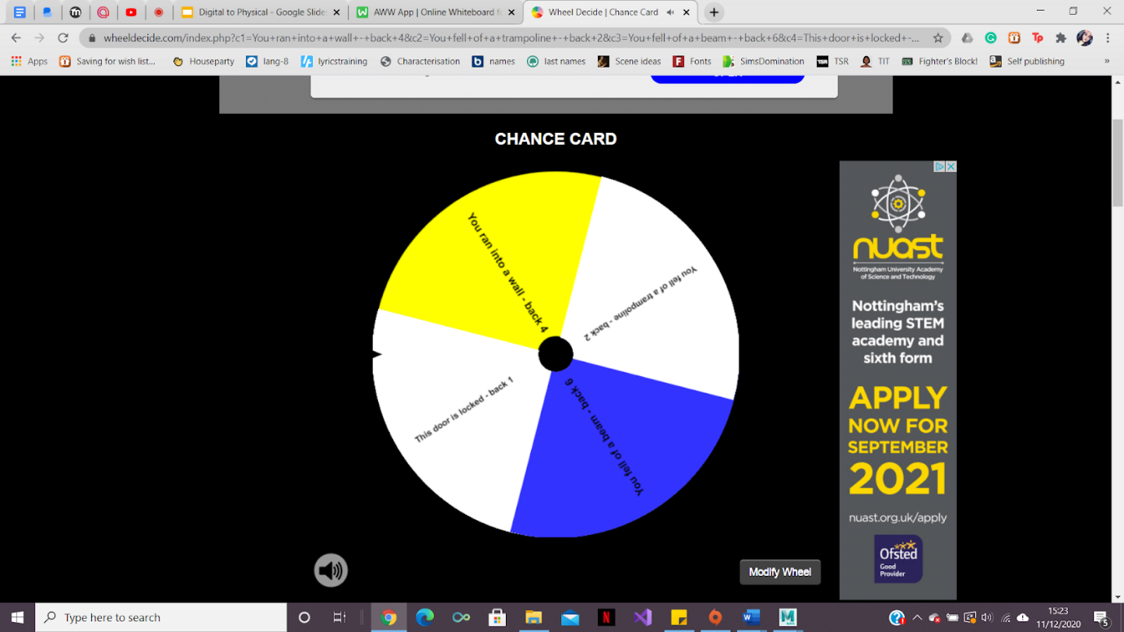

***Figure 2: A random generator for landing on the chance card square.***

**Example of Trivia questions:**

* How many players are allowed in one lobby for Fall Guys? 60
* What do you get when winning a game of Fall Guys? A crown
* What company developed Fall Guys? Mediatonic

**Rules:**

* Roll the dice to move
* Use random generator when landing on chance card. Make sure to move the spaces said.

**Playtesting:**

* Originally - the game was designed to have the players move back every chance card and move back if the trivia was wrong.
* During play testing, it was found that this would cause the game to be long as players were always moving backwards.
* Therefore, the game was improved by the trivia changing to moving the player forwards if they answered the question correctly.
* The number of cards moved forward depends on the difficulty of the question

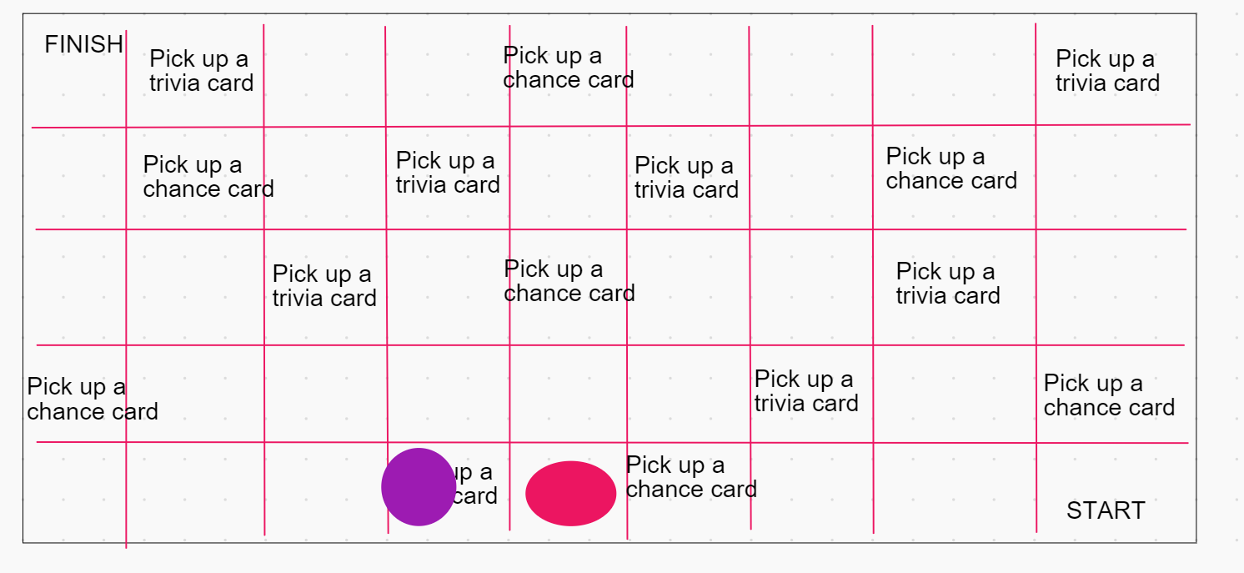

***Figure 3: The game board being play testing.***

**Project members:**

Members taken part in this project were Akash Sroay, Sienna Jenkins and Joshua Baker.

The external playtesting was done by Rowan Noble.